

**Department of Computer Science and Mathematics**

**CSC 491: Professional Experience**

Instructor:

Dr. Ramzi Haraty

Done by:

Nour Jalloul

Date: 1 August 2024

# Acknowledgement

Starting in June 2024, I undertook my internship at Areeba as part of completing my BS degree in Computer Science. The professional atmosphere at Areeba, characterized by commitment and hard work among developers, significantly contributed to my growth. The experience was invaluable, allowing me to gain important skills and knowledge.

I would like to thank Dr. Ramzi Haraty for his assistance and guidance throughout the course. I extend my appreciation to the faculty of the Department of Computer Science and Mathematics for their continuous support and for providing me with the academic foundation necessary to succeed in this internship.

Additionally, I would like to express my sincere gratitude to Areeba for this opportunity. Special thanks to Mr. Wajeeh Zantoot and Mr. Ali Berro for their guidance and support, which helped me build a solid foundation in web development. Their expertise has been instrumental to my learning and professional development.

Lastly, I am also grateful to the entire team at Areeba for their warm welcome and for creating an enjoyable and educational internship experience.

Contents

I. Acknowledgement 2

II. Abstract 5

III. Areeba 6

IV. About the Internship 7

V. The Technical Skills 8

(i)Assignments: 8

**(c). Assignment 3: React** 8

**(d). Assignment 4: React Router and State Management Store and Redux** 8

**(e). Assignment 5: Typescript** 8

**(f). Assignment 6: MongoDB Integration** 9

**(ii). Final Project: Robot_Friends Application** 9

**Project Overview** 9

**Project Details** 9

**Skills Acquired** 10

**Development Process** 10

**Scenario:** Upon visiting the website, users see a main page featuring a list of robots stored in the database. They can search for robots by name, add new ones with details such as name, username, email, and address, and view individual robot details by clicking on them. Each robot's details page allows users to update the robot's information or delete it. After making the desired changes, users can be redirected to the main page, which updates to reflect the latest data. 10

**Decision to Use NoSQL (MongoDB) Instead of SQL** 17

**Conclusion** 18

{/* 19

VI. The Soft Skills 19

*/} 19

VII. University Courses Used in the Internship 20

CSC 375 Databases Management Systems: 20

VIII. Future Expectations 21

IX. Conclusion 22

1. Letter of Intent……………………………………………………………………..…….25
2. Training Certificate…………………………………………………………………...……27
3. Employer's Signiture…………………………………………………………………….....28
4. References ………………………………………………………………………………..29

# Abstract

As part of the computer science program at LAU, students are prepared to engage with real-world challenges and to apply their academic learning in a professional setting. The internship program is designed to bridge the gap between theoretical knowledge and practical experience, equipping students with the skills needed for their future careers in technology.

During my internship at Areeba, which took place from June to July 2024, I had the opportunity to both learn new skills and apply the knowledge acquired during my university studies. The internship involved working on various web development projects, including the implementation and enhancement of an e-commerce website. I was tasked with making the site responsive using JavaScript, integrating React, Redux, and Typescript, and implementing CRUD operations with MongoDB.

This experience allowed me to gain hands-on experience in front-end and back-end development, state management, and user input validation among others. It also provided valuable insights into working collaboratively within a professional team and applying problem-solving skills to real-world challenges. The internship not only enhanced my technical capabilities but also refined my ability to navigate a professional environment.

This report highlights the different assignments and the final project undertaken during my internship, showcasing how both new and previously acquired skills were utilized in achieving project objectives and contributing to professional growth.

# Areeba

**{/\*** IDS, which stands for Integrated Digital Systems, is a leading software development company that provides Enterprise Resource Planning (ERP) products, Archiving Solutions, Document Management, Wealth Management, Online Trading, e-commerce, and e-government solution. The company designs and develops mobile applications and websites that assists business in acknowledging the power of data, social collaboration, cloud computing, and next generation tools for the enterprises (IDS,2018). The company is part of the Microsoft Partner Network and has been a Microsoft Certified Partner since 2001(IDS,2018). IDS builds programs that tackle business issues and strengths the use of technology to empower organizations to work all the more proficiently with more visibility and control over the supply chain. **\*/}**

**{/\***

Areeba is a leading technology company specializing in providing innovative solutions in the digital space. Established with the vision of transforming the technology landscape, Areeba is committed to delivering cutting-edge products and services that address the evolving needs of the industry.

The company’s mission is to empower businesses through technology by offering a range of services including software development, web development, and IT consultancy. Areeba focuses on leveraging the latest technologies to create scalable and efficient solutions that drive growth and success for its clients.

Areeba’s team of skilled professionals is dedicated to fostering a collaborative and dynamic work environment. The company emphasizes continuous learning and professional development, making it an ideal place for interns to gain practical experience and contribute to meaningful projects.

During my internship at Areeba, I had the opportunity to work on various web development projects, including implementing and enhancing an e-commerce website. This experience provided me with valuable insights into the company’s operations and the technology industry, furthering my understanding of professional practices and technological advancements.

**\*/}**

**//or use the linkedIn’s about**

# About the Internship

**{/\***The internship was a three months’ online internship about web programming using visual studio, where different assignments were posted to us via a forum online, explaining what we should do and providing different useful resources to learn form. The forum was a meeting point between the interns, where we switched knowledge between each other, in addition to being a bridge between the interns and the employees at the company where we could ask whatever wasn’t clear or what we couldn’t do. We also had to pass by once every week to present what we have done and discuss different ways of improving it. After being assigned different assignments during the first 2 months, a project was given in which we applied on all what has been learned.

**\*/}**

My internship at Areeba was a dynamic and hands-on experience in web development, spanning from June to July 2024. The internship was designed to immerse me in real-world web programming tasks and to provide practical experience with modern technologies.

The internship involved working on various assignments, which were provided through a collaborative platform. This platform served as a central hub for communication among interns, where we exchanged knowledge and collaborated on problem-solving. It also facilitated interaction with company employees, allowing us to seek guidance and clarify any uncertainties.

During the first part of the internship, I was tasked with implementing a home page for an e-commerce website based on a Figma design, and later worked on making the site responsive across different screen sizes. As I progressed, I continued to develop my skills in JavaScript, React, Redux, and TypeScript through a series of assignments and self-directed learning.

Each week, we were required to present our progress and discuss potential improvements with mentors and peers. This regular feedback loop helped refine our work and enhance our technical skills.

In the final phase of the internship, I applied everything I had learned to a comprehensive project. This project involved integrating CRUD operations with MongoDB and connecting the frontend with a backend server, demonstrating the practical application of the skills acquired throughout the internship.

Overall, the internship at Areeba provided a valuable opportunity to bridge academic learning with practical experience, contributing to both my professional development and my understanding of the technology industry.

# The Technical Skills

### (i)Assignments:

Throughout my internship at Areeba, I engaged in a variety of assignments that expanded my technical skills and practical knowledge. Below is an overview of these assignments and the skills I acquired.

**(a). Assignment 1: Web Page Development**

* **Description:** Created an e-commerce webpage incorporating essential web components such as headers, footers, images, lists, and formatted text, according to a given template. Then, implemented jQuery on the website to make it responsive.
* **Technologies Used:** HTML, CSS, jQuery.
* **Skills Acquired:** Enhanced my skills in structuring web pages with HTML and enhancing their appearance with CSS. Created a responsive layout with multiple sections along with navigation menus for them.

**(b). Assignment 2: Interactive Features with JavaScript**

* **Description:** Practiced JavaScript on freeCodeCamp tutorials and w3shools documentation which enhanced my understanding of it as a back-end language.
* **Technologies Used:** JavaScript.
* **Skills Acquired:** Gained experience in using JavaScript for form validation, altering the front-end elements and their CSS properties, event listeners, mapping, find, and CRUD.

**(c). Assignment 3: React**

* **Description**: Learned through documentation on [react.dev](https://react.dev) about React and its components. Applied the tutorial as a practice for the newly acquired knowledge.
* **Technologies Used**: React, Vite, Node.js.
* **Skills Acquired**: Learned to create a React app, and organize its components separately.

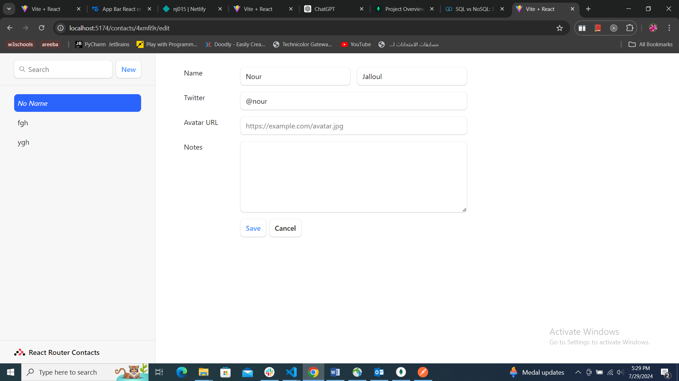 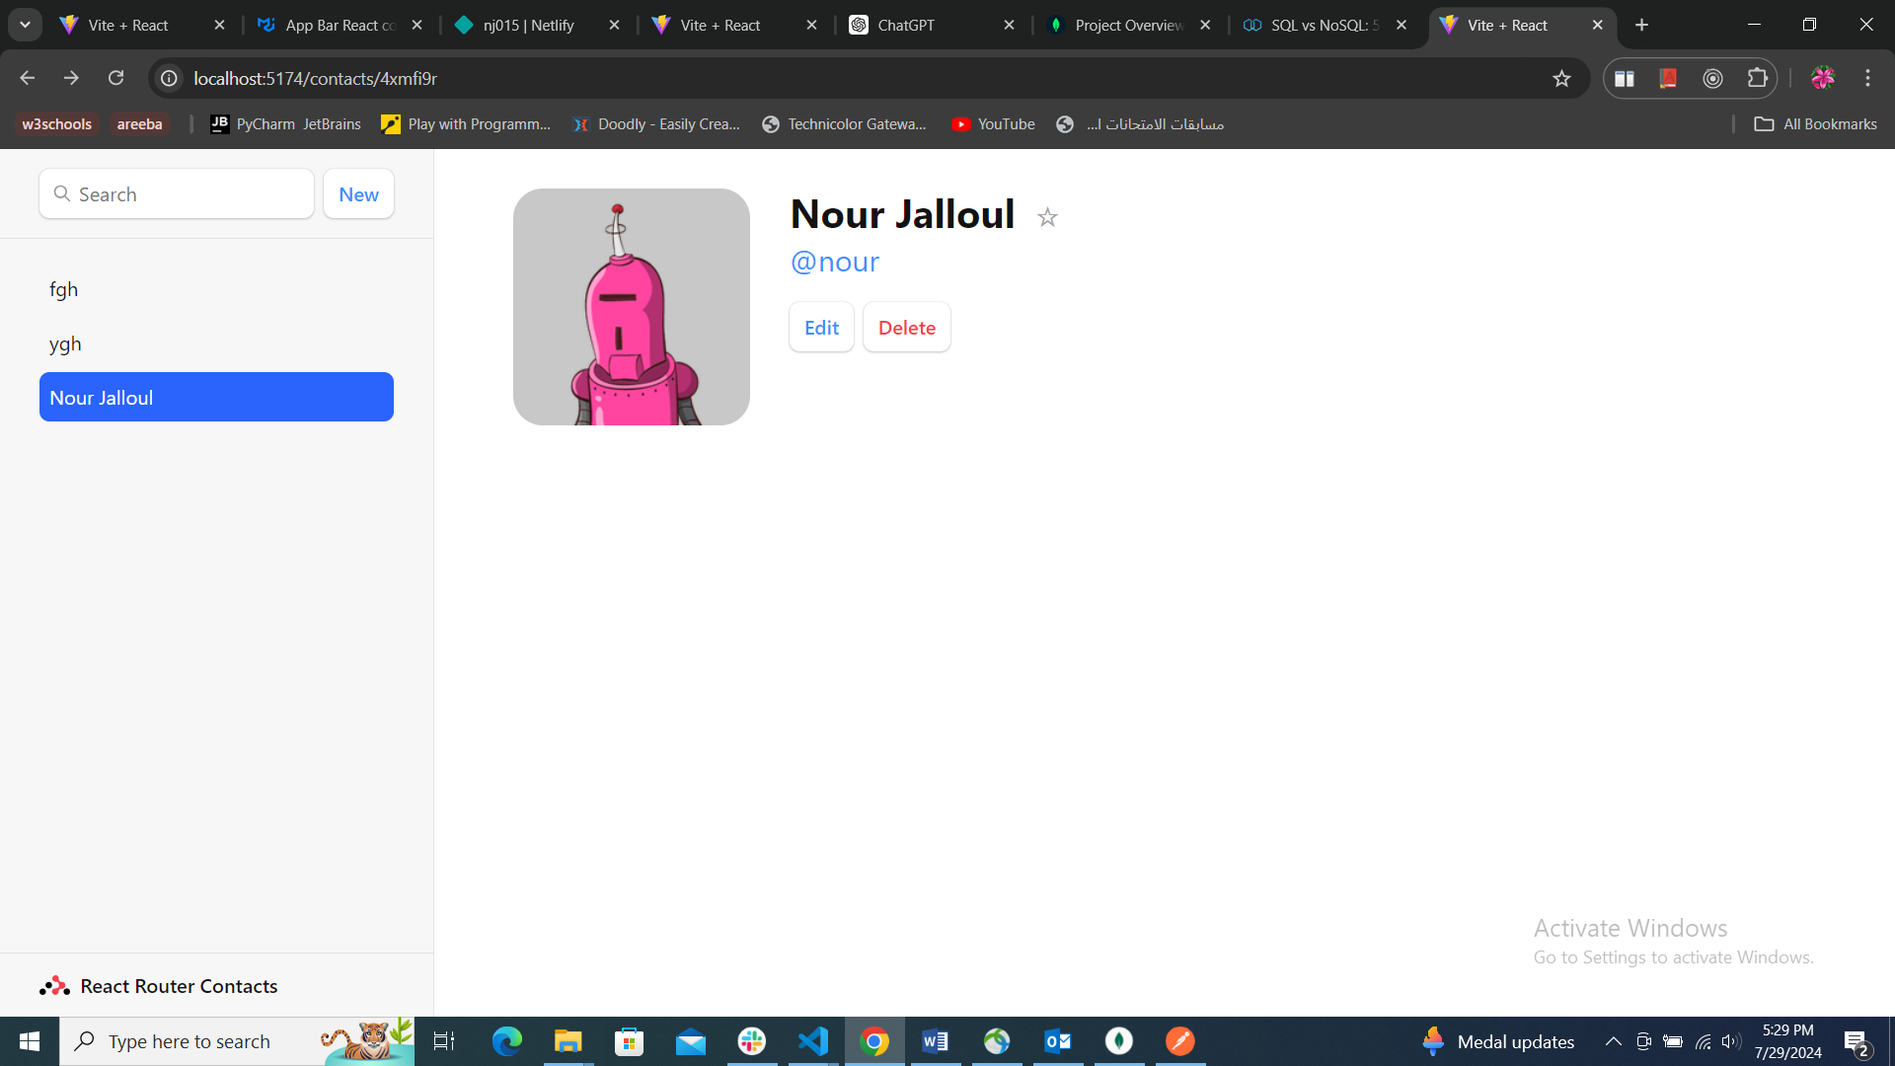

**(d). Assignment 4: React Router and State Management Store and Redux**

* **Description**: Explored React Router for managing navigation within the app and Redux for state management. Implemented routing to navigate between different components and used Redux to manage the global state.
* **Technologies Used**: React Router, Redux, React, Vite, Node.js.
* **Skills Acquired**: Gained proficiency in implementing routing in a React app, setting up and using Redux for state management, and integrating these technologies to create a seamless user experience.

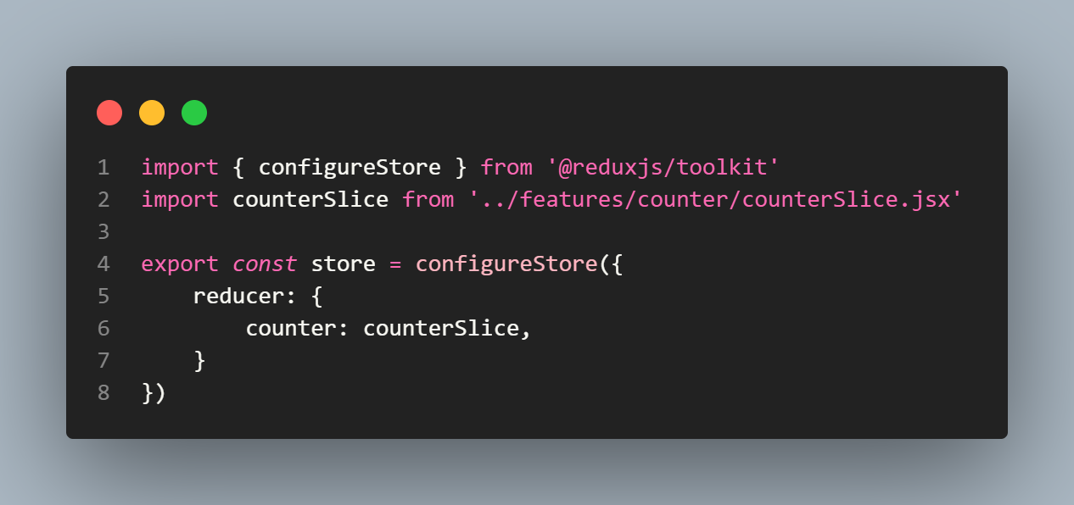 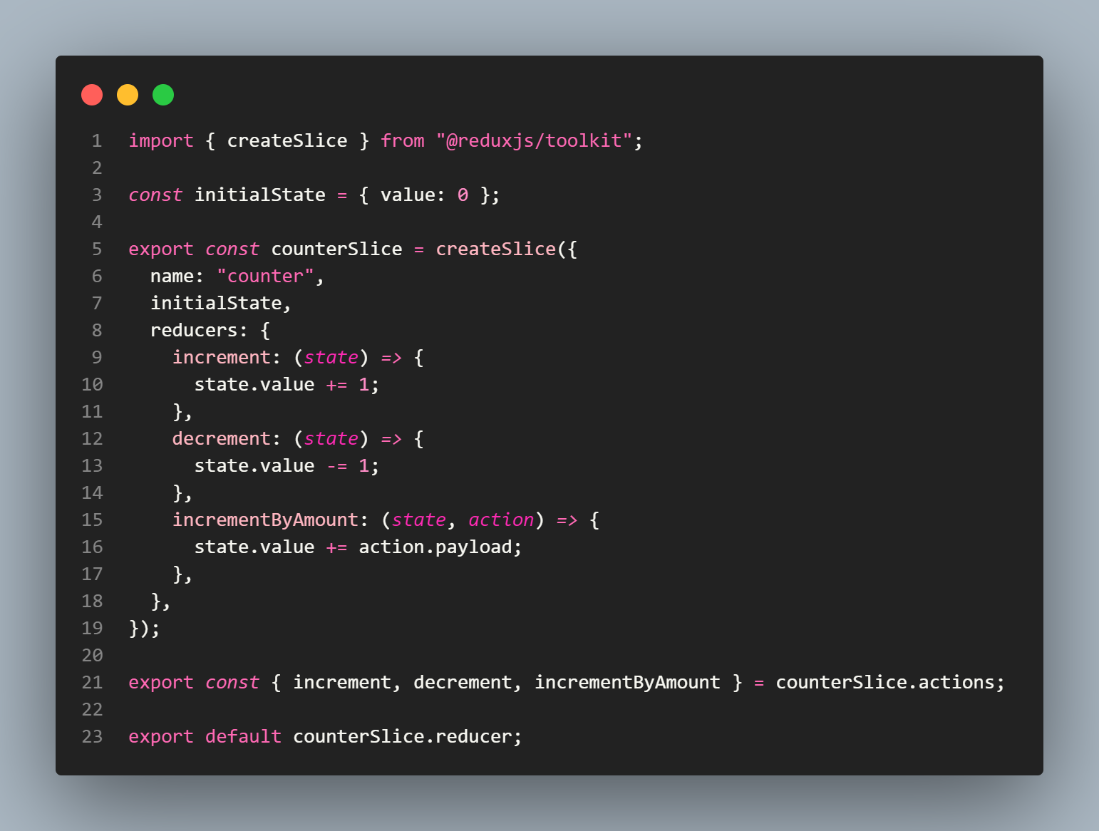 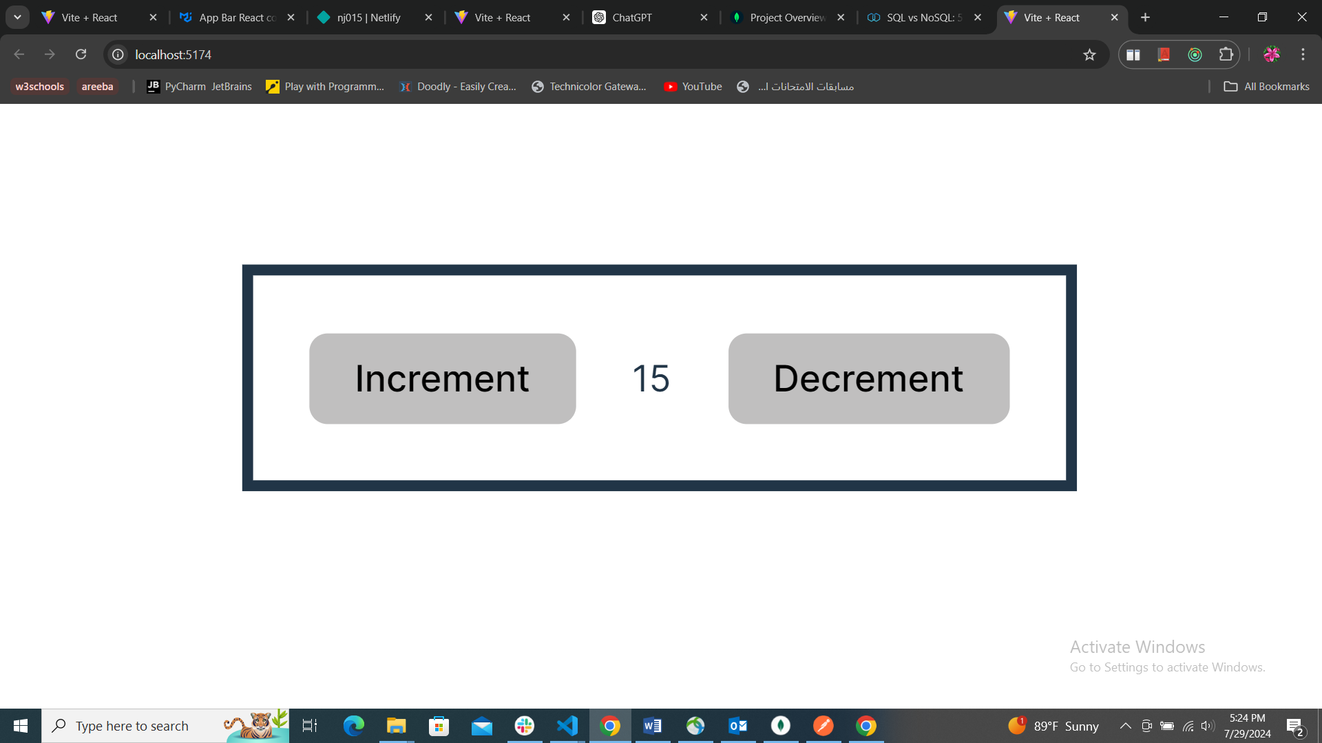

**(e). Assignment 5: Typescript**

* **Description**: Learned TypeScript through documentation and practiced it on the provided playground. Applied TypeScript to a React project to ensure type safety and improve code quality.
* **Technologies Used**: TypeScript, React, Vite, Node.js.
* **Skills Acquired**: Developed skills in using TypeScript for static typing in JavaScript applications, enhancing code maintainability and reducing bugs.

**(f). Assignment 6: MongoDB Integration**

* **Description** Completed an introductory tutorial on MongoDB, focusing on CRUD operations. This tutorial provided foundational knowledge of MongoDB, including setting up a database and performing create, read, update, and delete operations. The skills gained were crucial for integrating MongoDB into the project.
* **Technologies Used**: MongoDB, Node.js.
* **Skills Acquired**: Developed a solid understanding of MongoDB, including designing and managing a NoSQL database. Gained hands-on experience with CRUD operations and integrated MongoDB with a Node.js backend. This integration facilitated seamless data flow and efficient data management within the application.

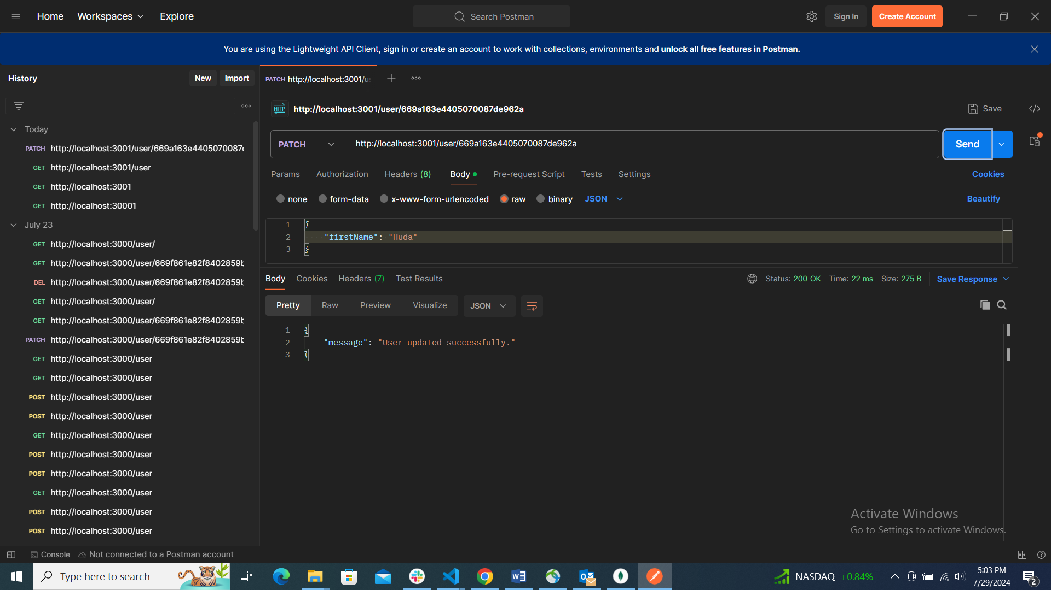

### **(ii). Final Project: Robot_Friends Application**

**Project Overview**

**Description:**  
The Robot_Friends application is a comprehensive project developed to integrate the various skills learned throughout the internship. The project started as a simple idea of creating a list of robotic friends, which evolved into a fully functional application with advanced features such as user management, state management, routing, and database integration. The goal was to apply the knowledge gained in a real-world scenario, creating an end-to-end web application from design to deployment.

**Technologies Used:**  
HTML, CSS, JavaScript, Node.js, React, React Router, Redux, MongoDB.

**Project Details**

**User Management:**  
Implemented features for adding, editing, and deleting users. Each user entry has detailed information, and the application provides a user-friendly interface to manage these users. The user details page was created using React Router to ensure smooth navigation within the app.

**API Integration:**  
The application connects to a backend server to perform CRUD (Create, Read, Update, Delete) operations. This was achieved using API principles, allowing for efficient data exchange between the front end and the back end.

**Database Integration:**  
MongoDB was chosen as the database for storing user data. The decision to use NoSQL instead of SQL was driven by the flexibility and scalability requirements of the project. MongoDB allows for dynamic schema design, which is ideal for handling the varied and nested data structures often found in user data. The database was connected to the backend server, ensuring seamless data storage and retrieval.

**Skills Acquired**

**Front-End Development:**

* **Advanced React Skills:** Developed a deep understanding of React components, state management, and hooks. Learned how to build complex interfaces and manage application state efficiently.
* **State Management with Redux:** Implemented Redux to manage the global state, enhancing data synchronization across components and reducing the need for prop drilling.

**Back-End Development:**

* **CRUD Operations:** Gained experience in developing and managing CRUD operations in a Node.js environment.
* **API Development:** Created and integrated an API to enable communication between the front end and the back end.
* **MongoDB Database Management:** Learned how to design, implement, and manage a NoSQL database using MongoDB.

**Project Management:**

* **End-to-end Development:** Successfully managed the entire development lifecycle, from initial design to final deployment. Learned how to plan, execute, debug and monitor a project, ensuring all components work seamlessly together.

**Development Process**

**How the Project Came to Be:** The project idea stemmed from the need to create a practical application that encapsulated the skills learned during the internship. The concept of a robotic friends list was simple yet expandable, providing a perfect canvas to implement various features and technologies. The initial task was to create a static list, but as the project progressed, new features were added, transforming it into a dynamic and interactive application.

**Scenario:** Upon visiting the website, users see a main page featuring a list of robots stored in the database. They can search for robots by name, add new ones with details such as name, username, email, and address, and view individual robot details by clicking on them. Each robot's details page allows users to update the robot's information or delete it. After making the desired changes, users can be redirected to the main page, which updates to reflect the latest data.

**Timeline Process:**

**June 27-28:**

* **Initial Setup:** Created the static version of the Robot_Friends application using basic HTML, CSS, and JavaScript. Integrated React Router DOM to handle routing within the app. Created a search bar to facilitate finding the required robot.

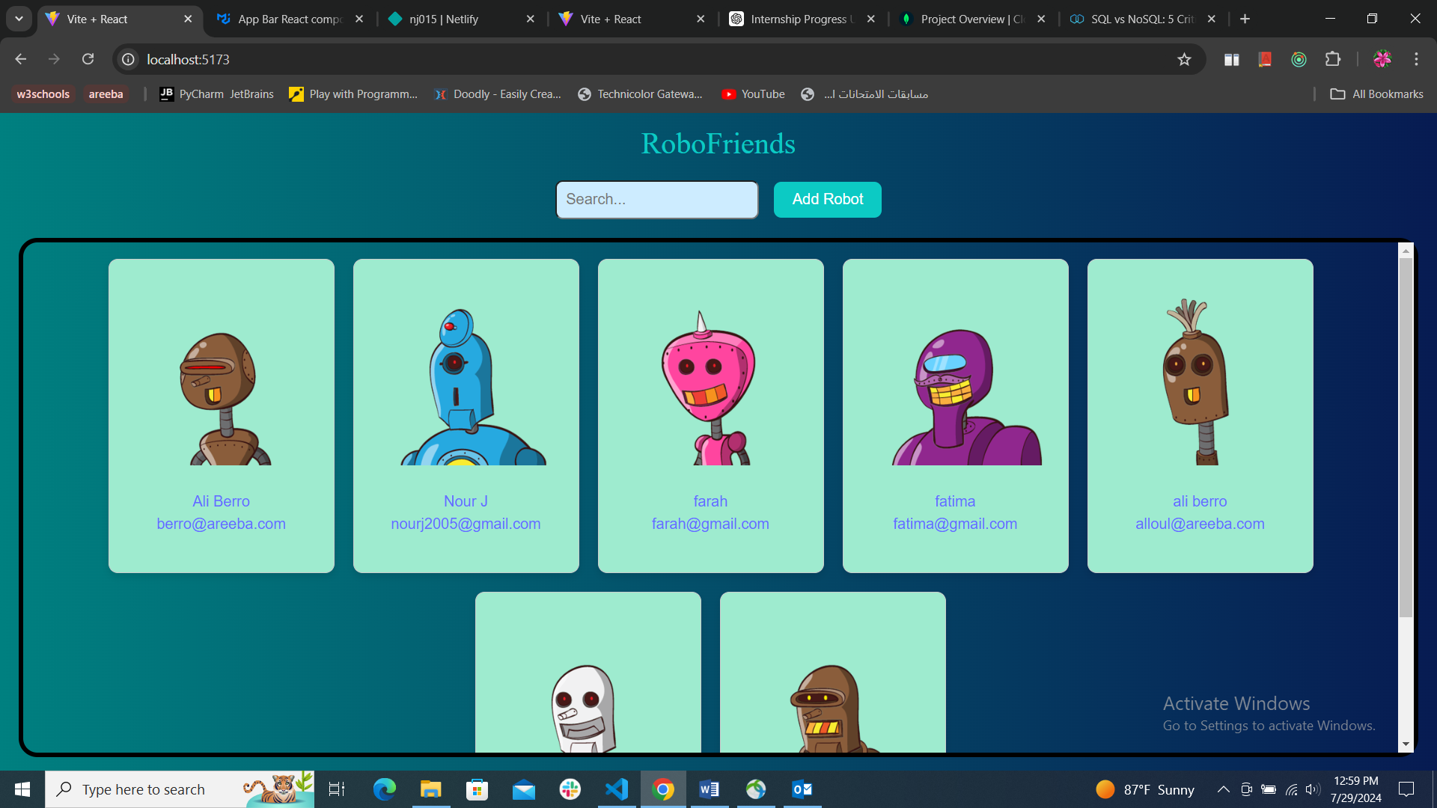

**June 29 - July 1:**

* **Routing Enhancements:** Continued working with React Router DOM, implementing nested routes and dynamic route parameters to improve navigation and user experience.

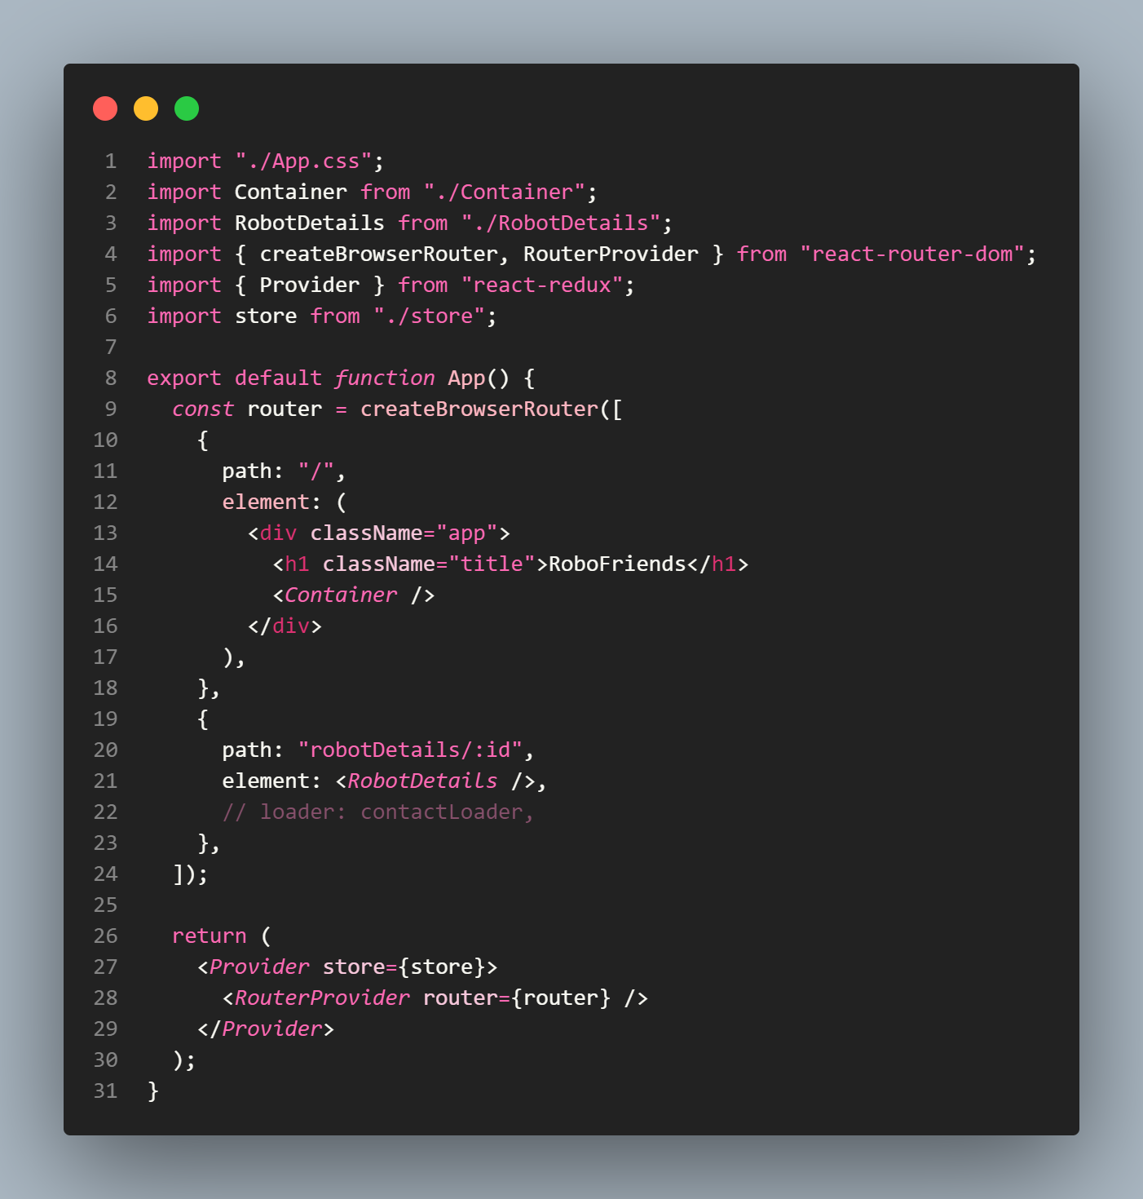

**July 9:**

* **Add User Feature:** Added a feature to allow users to add new robotic friends. This involved creating a form component and managing form state using React hooks.

 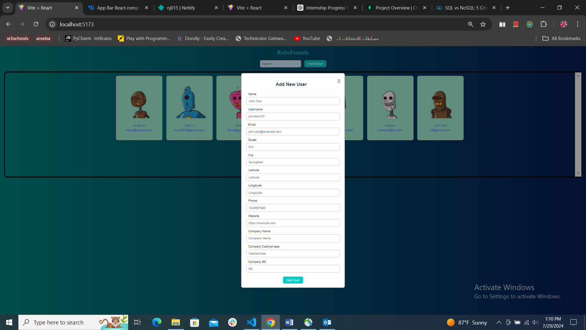

**July 10:**

* **Details Page:** Implemented a user details page using React Router. Each robot in the list now links to a detailed view, displaying all relevant information about the robot.

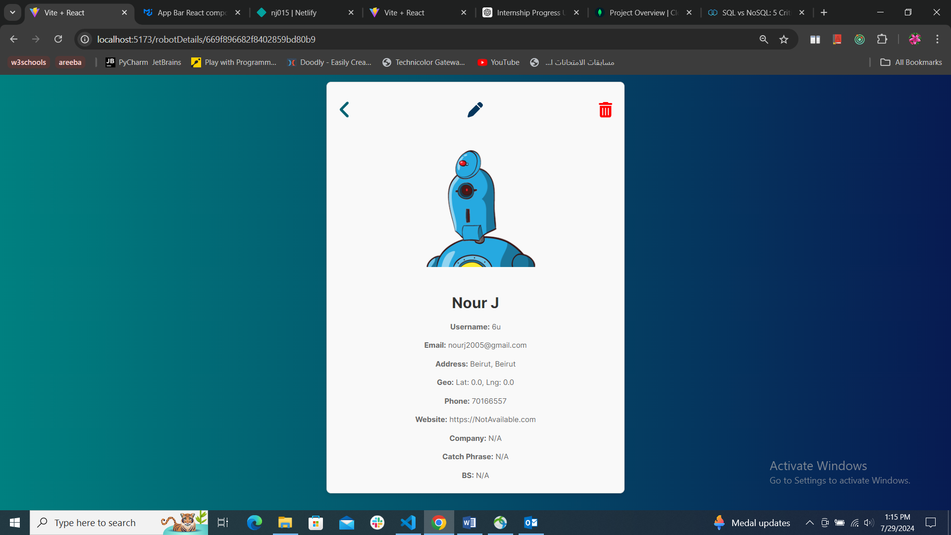

**July 11:**

* **State Management:** Introduced Redux for state management. Defined actions, reducers, and the store to handle application state efficiently. This reduced the complexity of passing props through multiple components and improved data flow consistency.

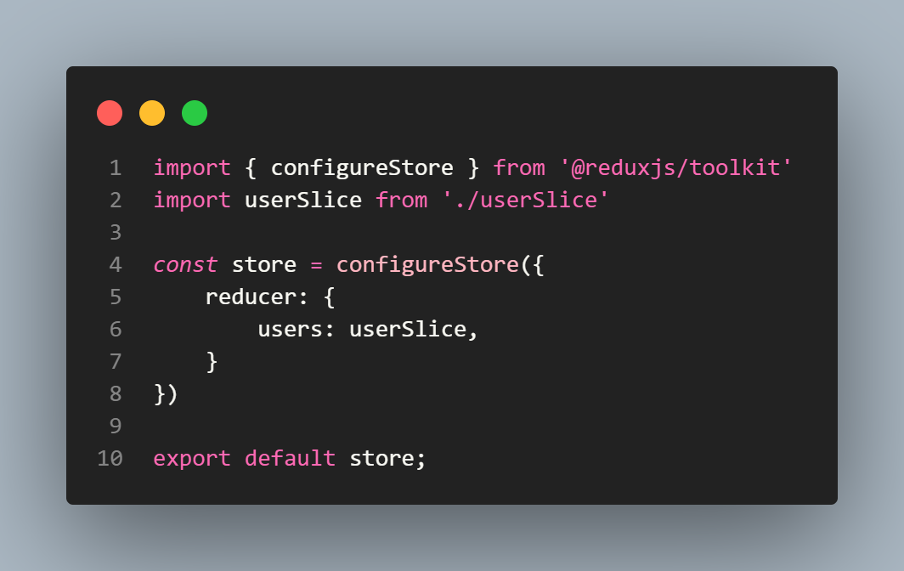

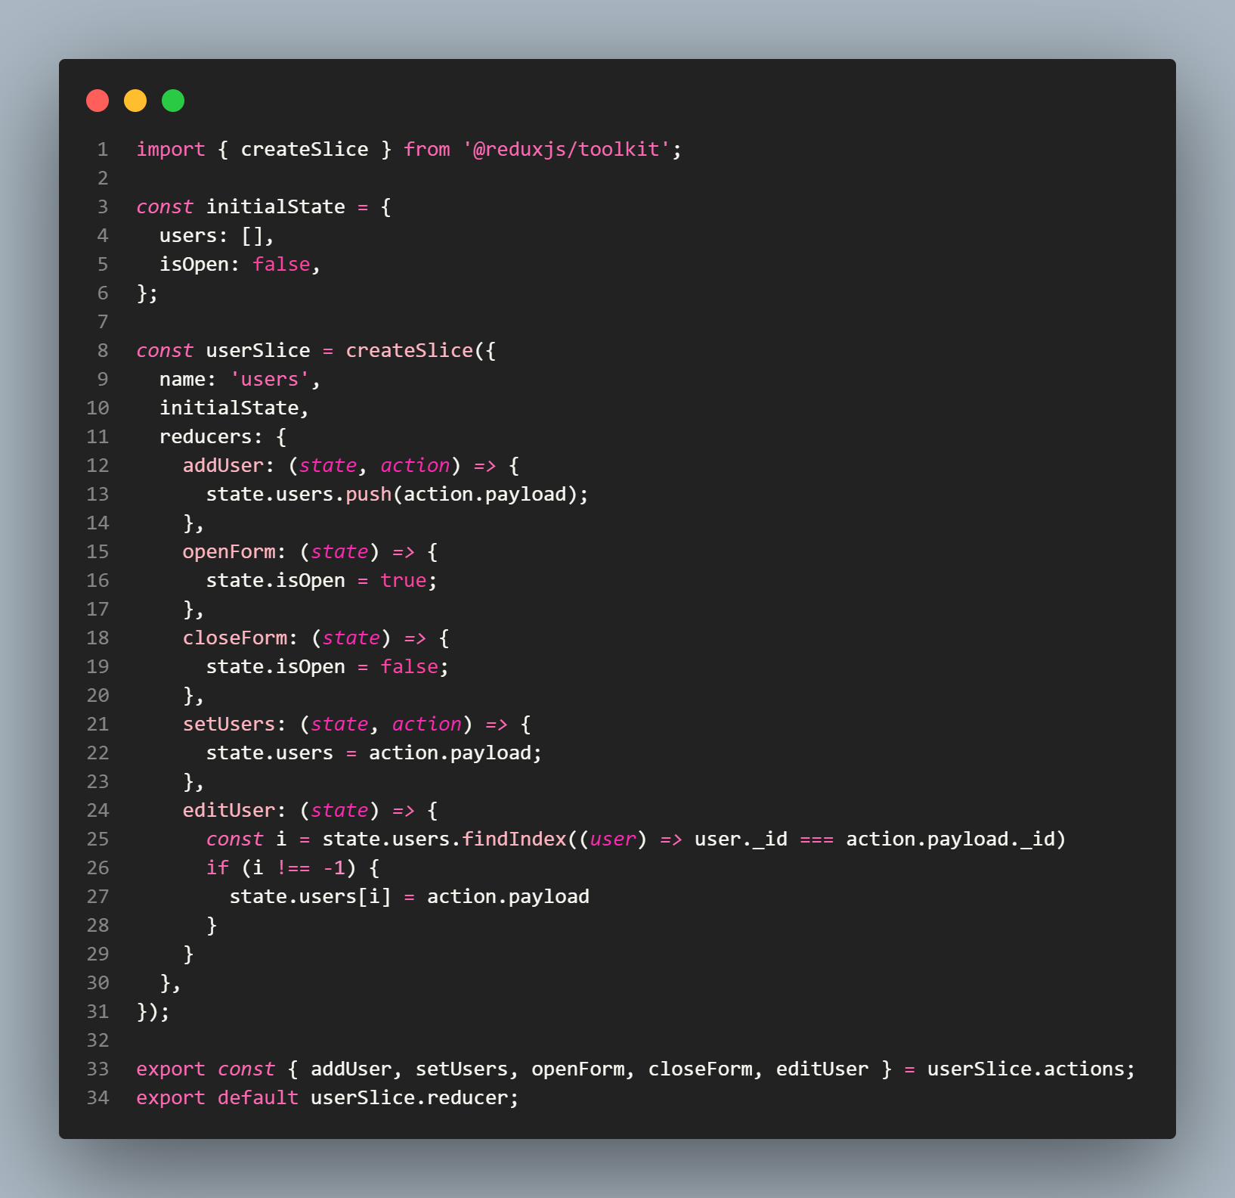

**July 12:**

* **Form Validation:** Integrated Formik and Yup to handle form validation for adding users. This ensured that all user inputs were validated before submission, improving data integrity.

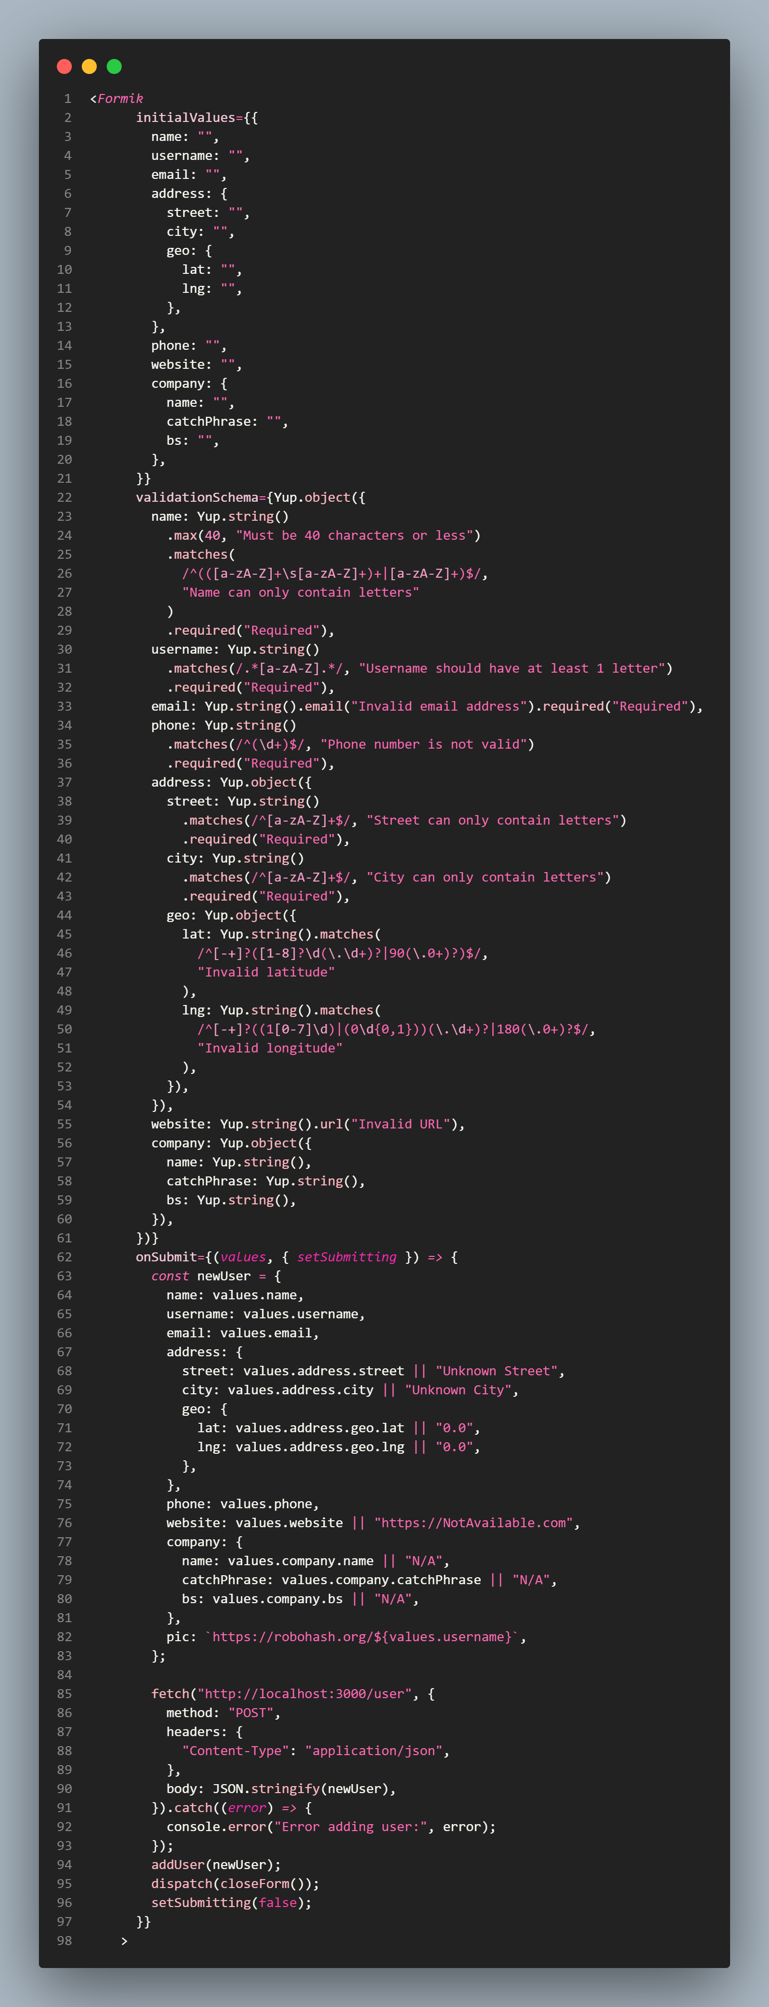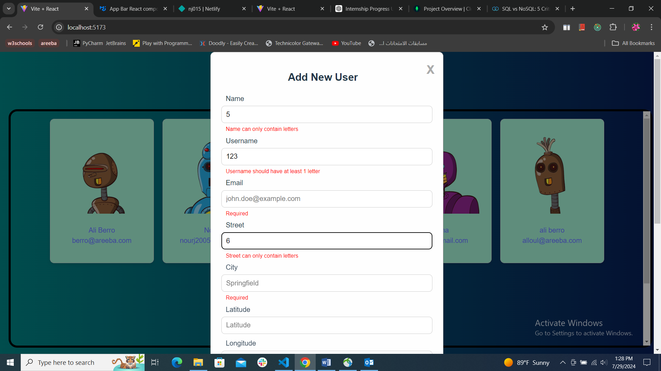

**July 15-18:**

* **API Integration:** Implemented an API into the project to fetch user information from a dummy JSON API temporarily. This transitioned the user data from static JSON to dynamic data fetched from the backend server.

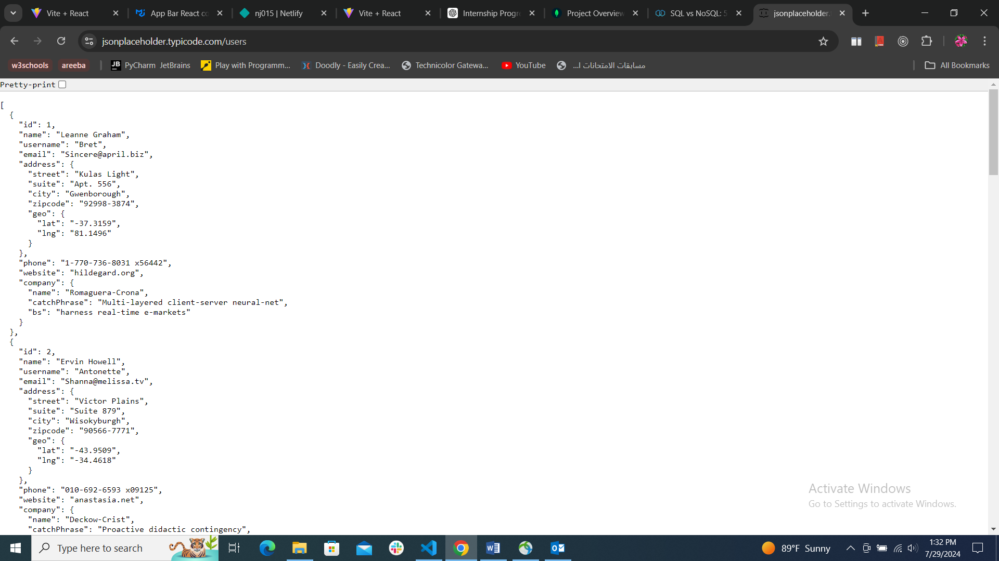

**July 19-23:**

* **CRUD Operations with MongoDB:** Integrated CRUD operations into the Robot_Friends application. This involved connecting the MongoDB database to the backend server and implementing endpoints to create, read, update, and delete user data.

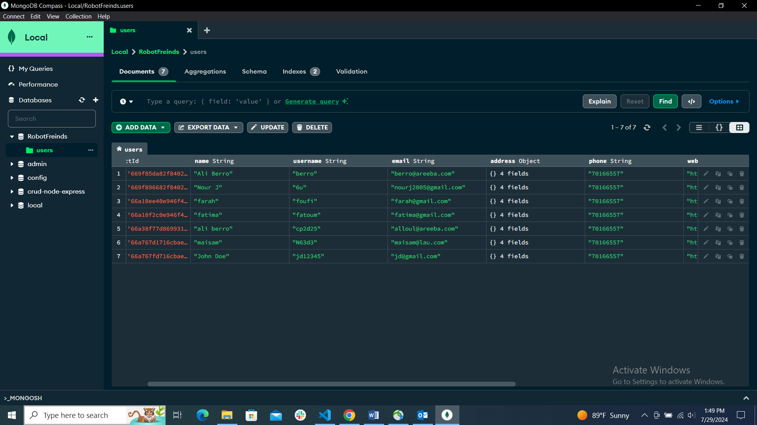 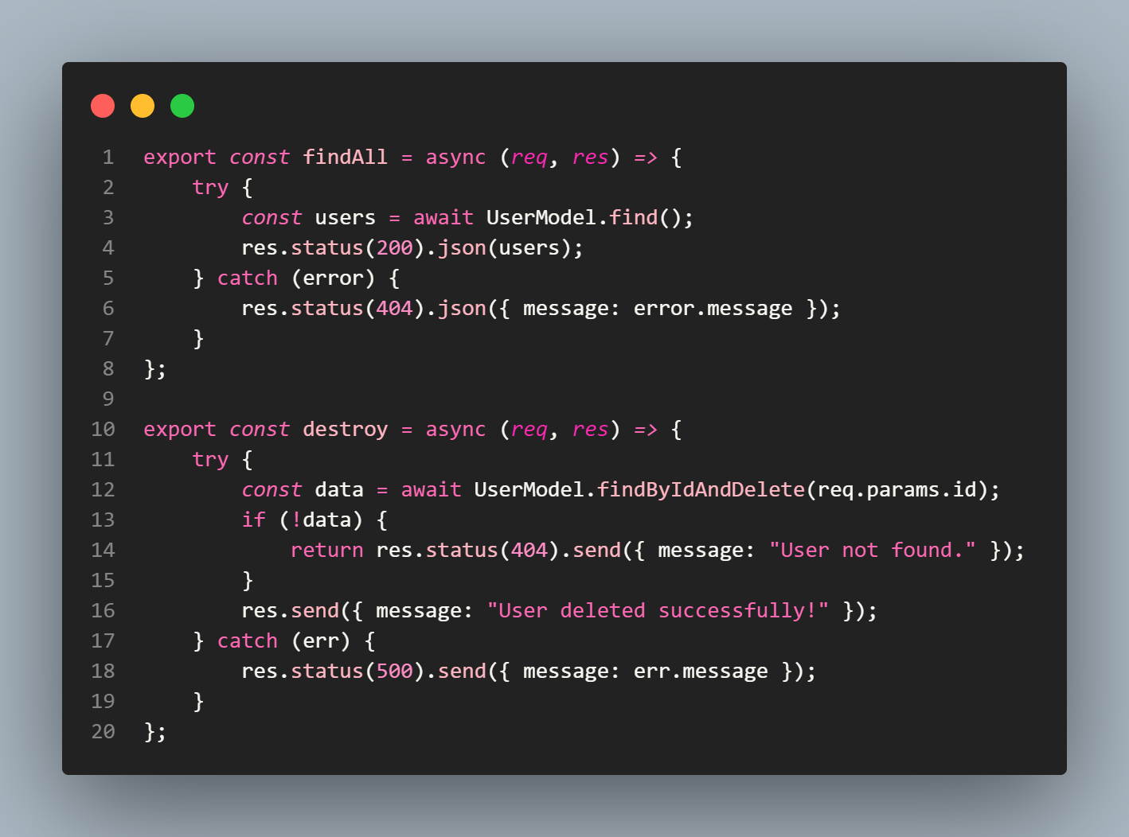 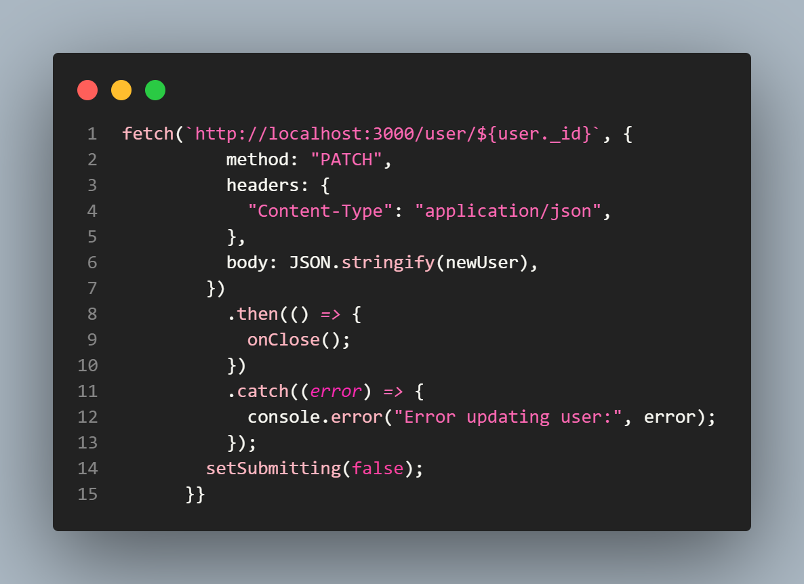

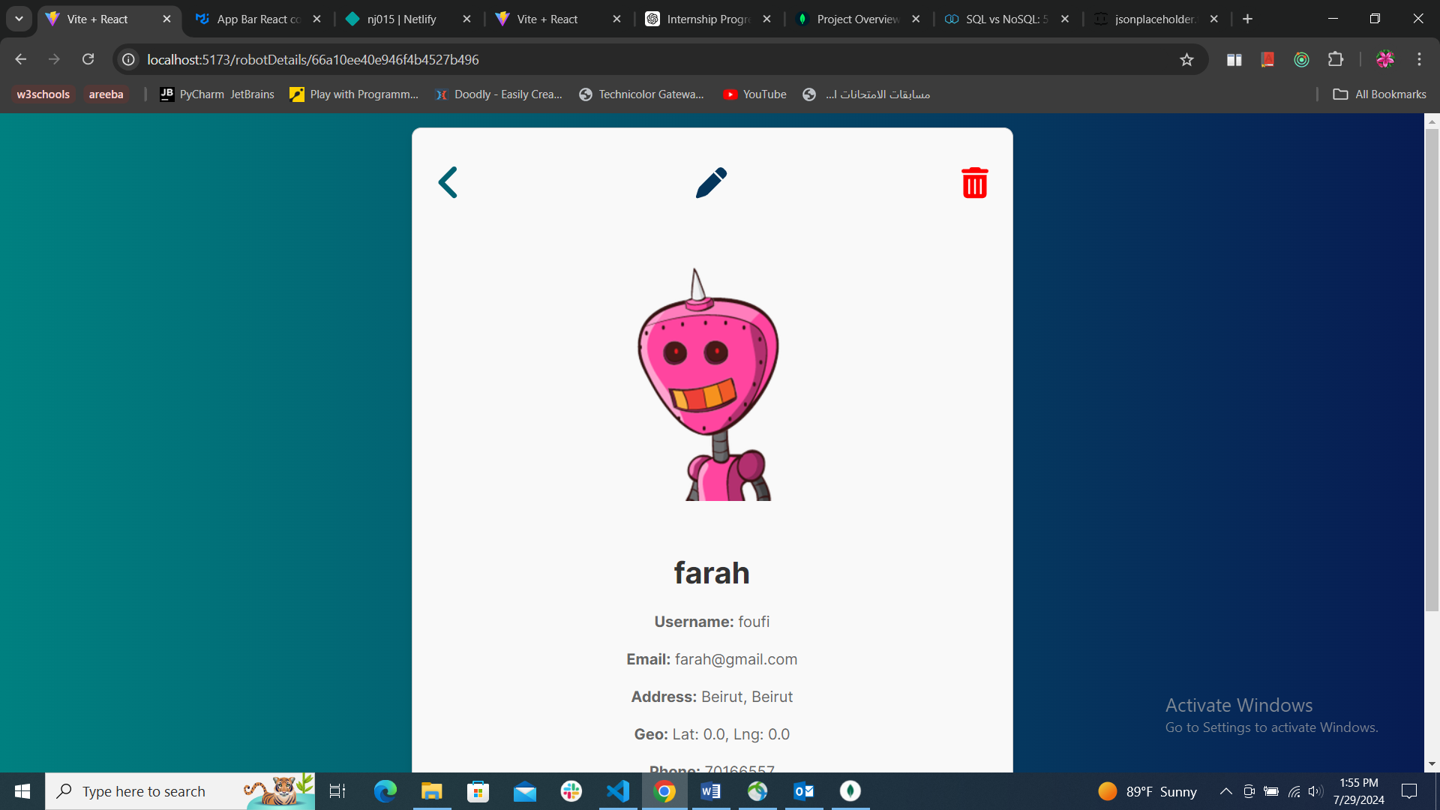

{/*

Pending deployment to netlify

*/}

**Decision to Use NoSQL (MongoDB) Instead of SQL**

The decision to use MongoDB was driven by several factors:

1. **Flexibility:** MongoDB's schema-less nature allows for more flexible data modeling, accommodating changes in data structure without requiring schema migrations.
2. **Scalability:** MongoDB is designed to handle large volumes of data and high-throughput operations, making it ideal for applications expected to grow over time.
3. **Ease of Use:** MongoDB's document-based storage aligns well with the JSON format used in the application, simplifying data handling and manipulation.

This decision ensured that the project could handle varying data requirements and scale effectively as the number of users increased.

**Conclusion**

This final project was an amalgamation of all the skills and knowledge acquired during the internship. It provided hands-on experience in both front-end and back-end development, offering a holistic view of web application development. The journey from a static list to a fully functional, dynamic application was filled with learning opportunities, challenges, and achievements. This experience not only enhanced my technical skills but also boosted my confidence in managing and delivering a complete project.

# {/*

# The Soft Skills

**(i). Communication Skills**

Effective communication is crucial for successful project development. Throughout my internship at Areeba, I recognized the importance of clearly conveying ideas, discussing project structures, and addressing issues with team members. Strong communication skills facilitated better collaboration, allowing me to explore various aspects of the project thoroughly and achieve optimal outcomes. Being able to articulate ideas and provide constructive feedback helped in resolving challenges and enhancing the overall quality of the work.

# */}

# University Courses Used in the Internship

## CSC 375 Databases Management Systems:

The concepts and techniques learned in CSC 375 were directly applicable to my internship tasks. The course provided a solid foundation that was crucial for developing the backend of the Robot_Friends project. The knowledge of SQL language and relational database design allowed me to effectively implement and manage databases using MongoDB for CRUD operations. This course equipped me with the skills to create, query, and manipulate databases, which proved essential for integrating the database with the frontend of my project.

**CSC 490 Software Engineering**

CSC 490 was instrumental in understanding the broader software development lifecycle. The course's focus on software architecture, design patterns, and project management principles was particularly relevant. During my internship, I applied these principles to develop a structured approach for both the front end and back end of the Robot_Friends application.

**CSC 443 Web Development**

The web development course provided essential knowledge for building and styling web applications. The skills acquired in CSC 443 were applied throughout my internship, from creating responsive designs to implementing interactive features using HTML, CSS and JavaScript. The course’s focus on both frontend and backend development helped me effectively integrate various technologies into the Robot_Friends project. Understanding web development tools was crucial for developing a dynamic and user-friendly application. The practical experience gained in this course was reflected in the successful implementation of the final project.

# Future Expectations

This internship has been essential in shaping my understanding of the web development field and the various career opportunities within it. Through hands-on experience with technologies such as JavaScript, React, Redux, Typescript, CRUD, and MongoDB, I have gained valuable insights into the practical aspects of web development. The exposure to both frontend and backend development has broadened my perspective on the roles and responsibilities within this domain.

I now have a clearer vision of the skills required for different positions in web development and the types of projects that align with my interests and career goals. The experience has also highlighted the importance of continuous learning and adaptability in the ever-evolving tech landscape. Moving forward, I am excited to apply the skills and knowledge gained during this internship to future projects and explore further opportunities in web development.

# Conclusion

This internship has proven to be an invaluable experience, offering a deep dive into the practical aspects of web development. Starting with limited knowledge in web programming, I was able to acquire foundational skills and understand the diverse roles within the field, such as frontend and backend development. The hands-on experience exposed me to real-world challenges and demonstrated that ongoing self-learning, effective communication, and collaboration are crucial for overcoming obstacles and achieving success.

The internship not only enhanced my technical skills but also boosted my self-confidence and sense of responsibility. By tackling various assignments and learning from experienced developers, I gained practical insights into the industry and developed a better understanding of how to navigate and address challenges. This experience has solidified my commitment to pursuing a career in web development and equipped me with the skills and mindset necessary for future endeavors.

24

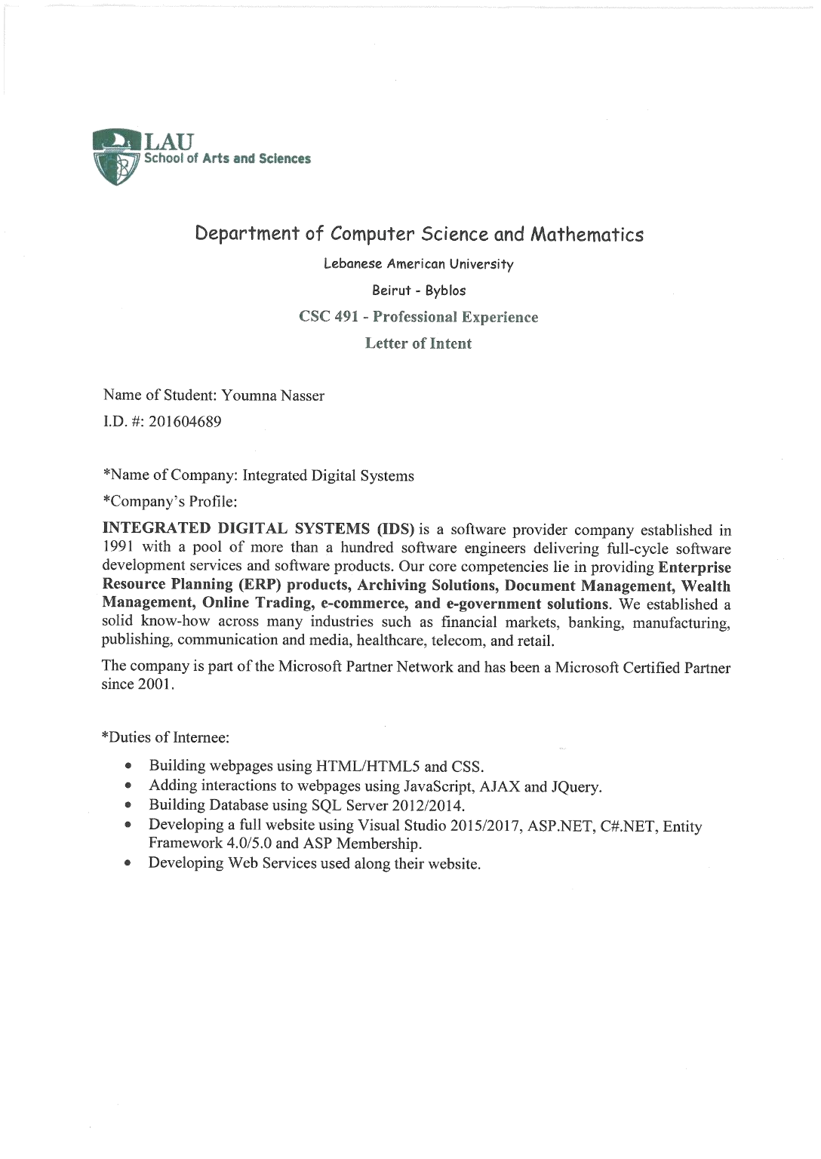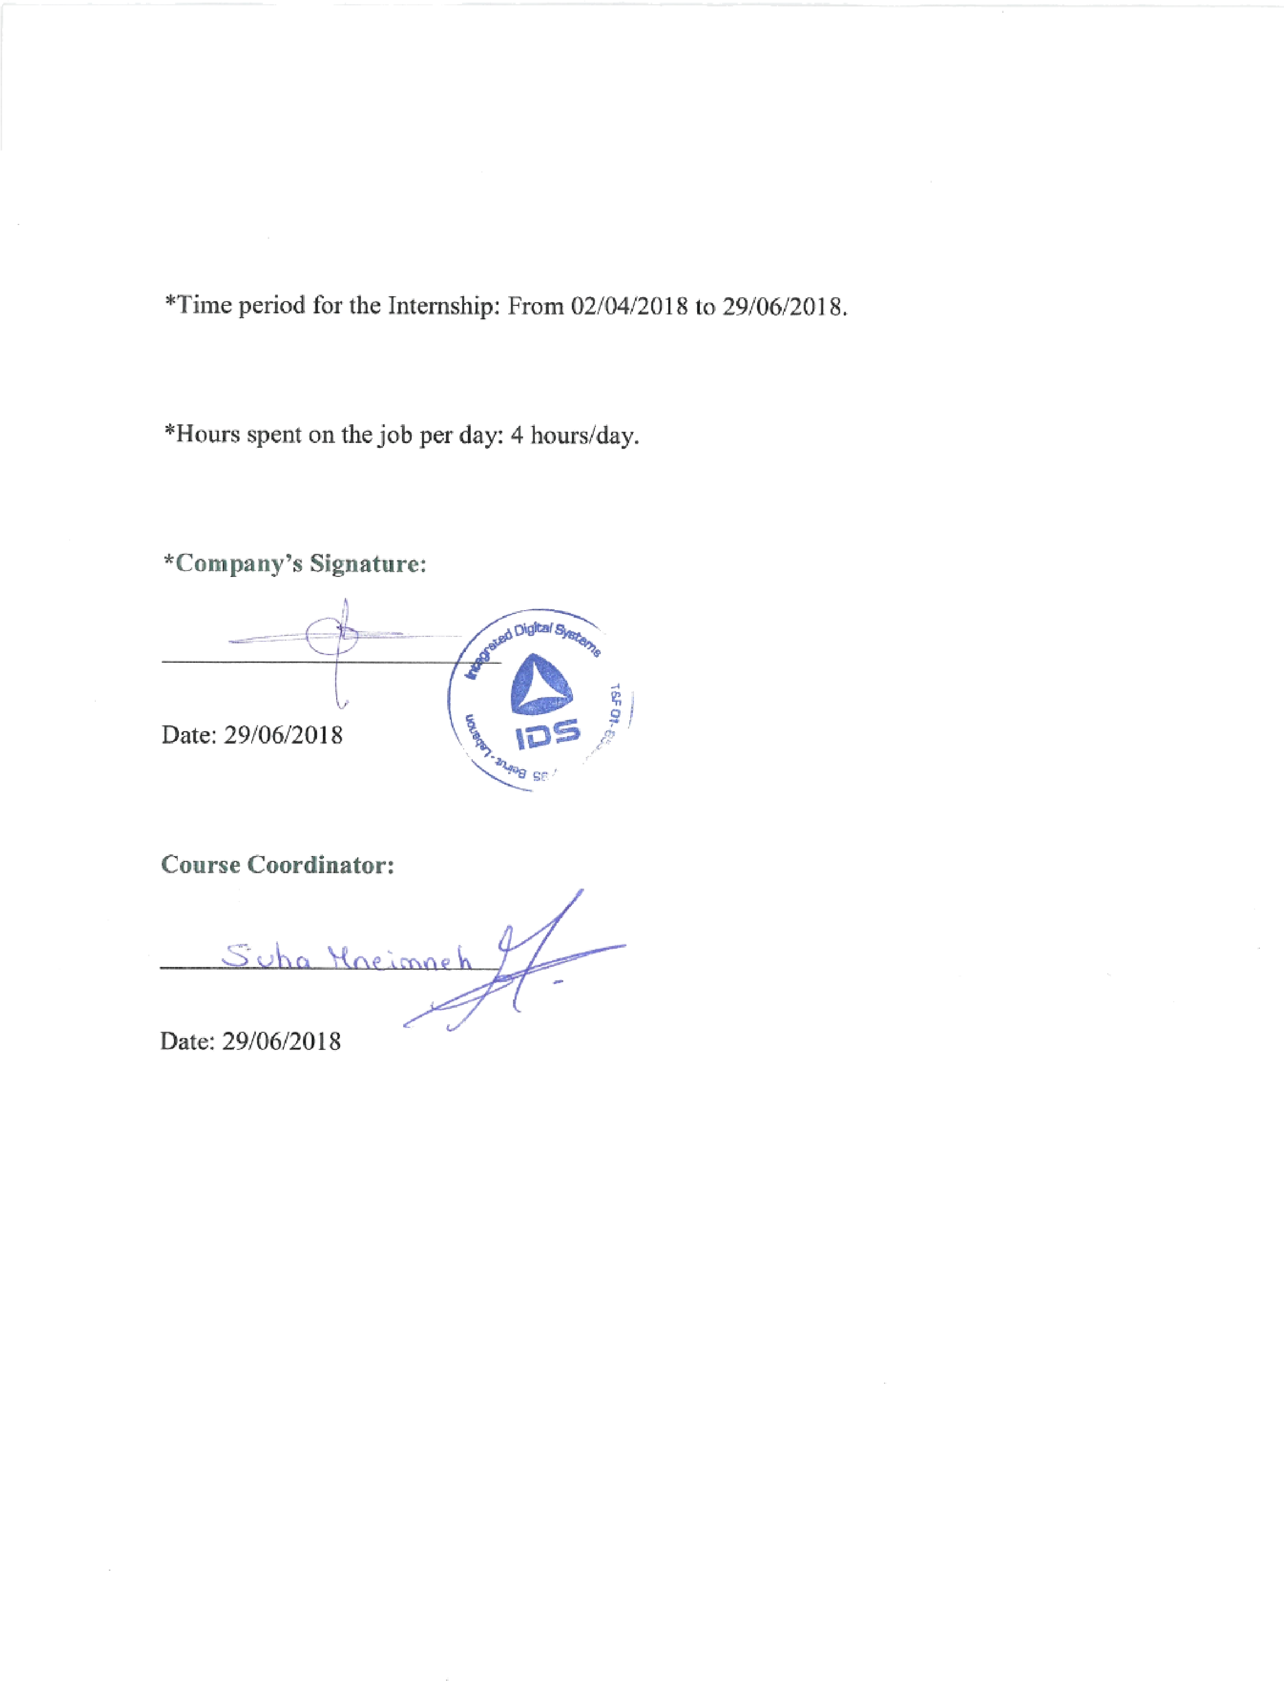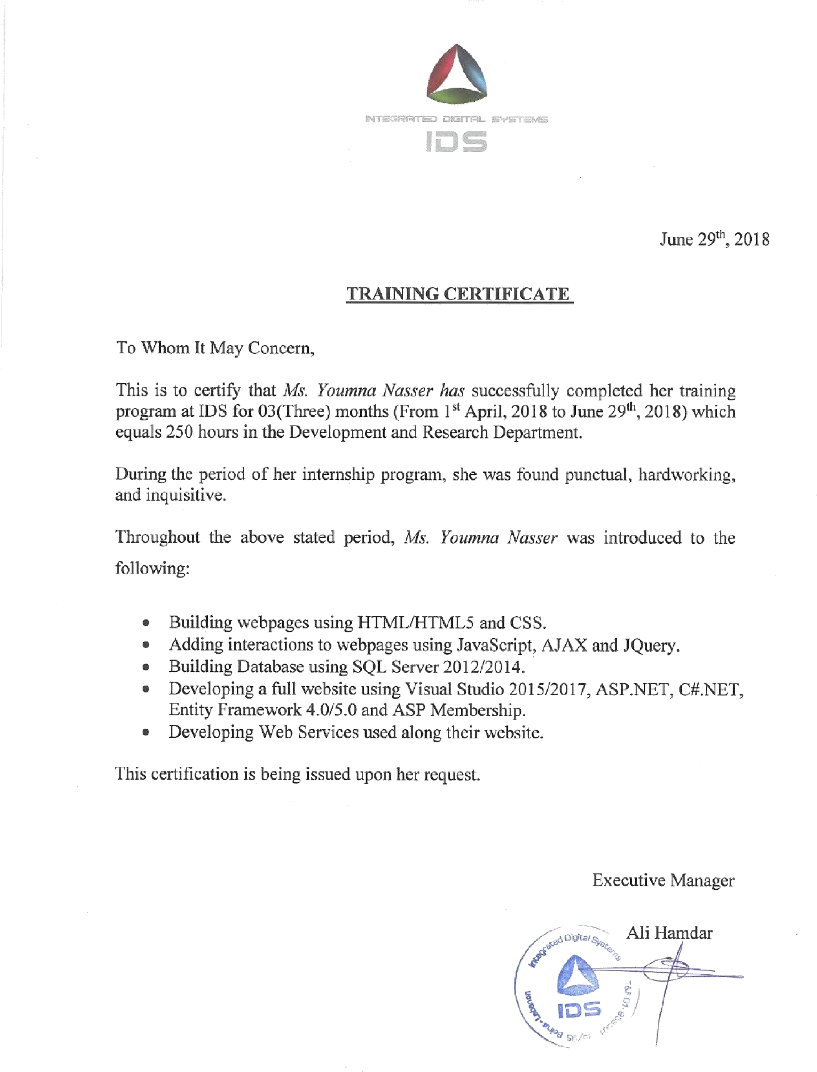

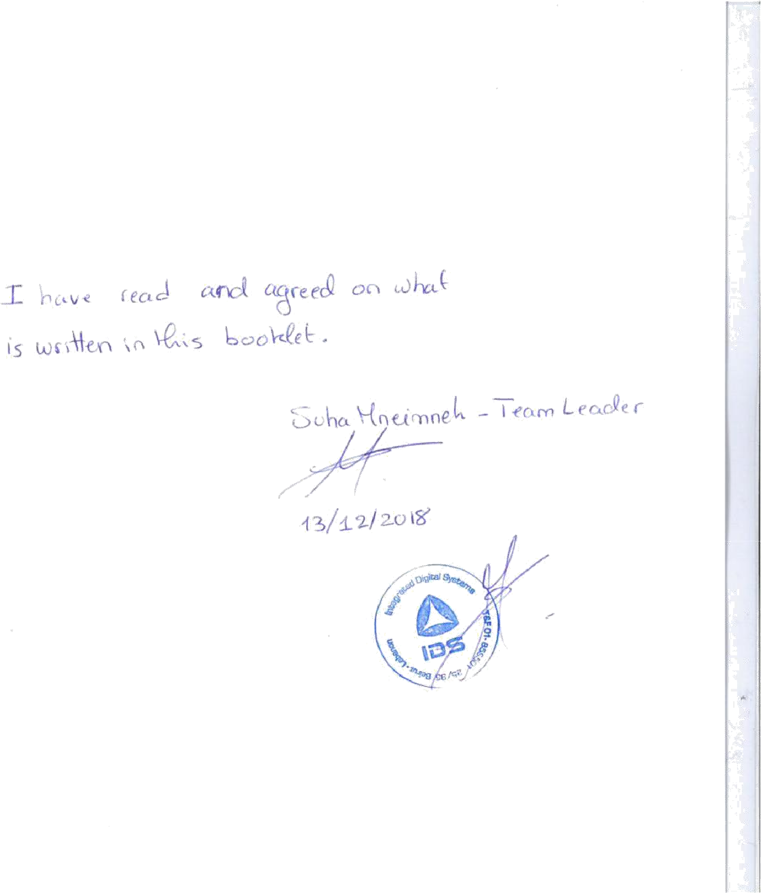

X.References

<http://www.entityframeworktutorial.net/what-is-entityframework.aspx>

[https://docs.microsoft.com/en-us/dotnet/framework/wcf/feature-details/how-to-use-the-aspnetmembership-provider](https://docs.microsoft.com/en-us/dotnet/framework/wcf/feature-details/how-to-use-the-aspnet-membership-provider) <http://www.ids.com.lb/who-we-are>

<https://github.com/NJ015/My_Internship>

<https://github.com/NJ015/MyAreebaInternship>

[https://aneagoie.github.io/Robot_Friends/](https://aneagoie.github.io/robofriends/)

<https://robohash.org/2size=200x200%60>

<https://redux-toolkit.js.org/>

<https://redux-toolkit.js.org/tutorials/quick-start>

<https://www.typescriptlang.org/docs/handbook/typescript-from-scratch.html>

* <https://www.typescriptlang.org/docs/handbook/2/basic-types.html>
* <https://www.typescriptlang.org/docs/handbook/2/functions.html>
* <https://www.typescriptlang.org/docs/handbook/2/everyday-types.html>
* <https://www.typescriptlang.org/docs/handbook/2/objects.html>

<https://formik.org/docs/tutorial>

<https://medium.com/techvblogs/build-crud-api-with-node-js-express-and-mongodb-e3aa58da3915>

<https://mui.com/material-ui/getting-started/installation/>

<https://mui.com/material-ui/getting-started/learn/>

<https://medium.com/techvblogs/build-crud-api-with-node-js-express-and-mongodb-e3aa58da3915>

<https://formik.org/docs/tutorial>

<https://legacy.reactjs.org/docs/conditional-rendering.html#:~:text=Conditional%20rendering%20in%20React%20works,the%20UI%20to%20match%20them.&text=This%20example%20renders%20a%20different,the%20value%20of%20isLoggedIn%20prop>.

<https://jsonplaceholder.typicode.com/>

<https://react.dev/reference/react/hooks>

<https://redux.js.org/tutorials/fundamentals/part-1-overview>

<https://redux.js.org/tutorials/essentials/part-1-overview-concepts>

<https://react.dev/learn/managing-state>

<https://reactrouter.com/en/main/routers/create-browser-router#createbrowserrouter>

<https://www.freecodecamp.org/news/reactive-programming-beginner-guide/>

<https://legacy.reactjs.org/docs/create-a-new-react-app.html>

<https://nodejs.org/en>

<https://react.dev/learn/add-react-to-an-existing-project>

<https://react.dev/learn/installation>

<https://www.w3schools.com/js/js_string_search.asp>

<https://www.w3schools.com/js/js_string_methods.asp>

<https://www.w3schools.com/js/js_strings.asp>

<https://www.w3schools.com/js/js_arrays.asp>

<https://www.w3schools.com/js/js_array_methods.asp>

<https://www.w3schools.com/js/js_array_search.asp>

<https://www.w3schools.com/js/js_array_sort.asp>

<https://www.w3schools.com/js/js_switch.asp>

<https://www.w3schools.com/js/js_if_else.asp>

<https://www.w3schools.com/js/js_json.asp>

<https://www.w3schools.com/js/js_arrow_function.asp>

<https://www.w3schools.com/js/js_classes.asp>

<https://www.freecodecamp.org/news/top-javascript-concepts-to-know-before-learning-react/>

<https://www.w3schools.com/css/css_rwd_mediaqueries.asp>

<https://www.freecodecamp.org/learn/javascript-algorithms-and-data-structures-v8/>

<https://www.freecodecamp.org/learn/2022/responsive-web-design/#learn-html-by-building-a-cat-photo-app>

<https://flexboxfroggy.com/>

<https://www.figma.com/design/7UMHq4rNMaBHPwLUcxnJ11/Retail-E-Commerce-Website-Design-(Community)?node-id=3-447>